Computer Networking MCIS 6163 Project 1: Simple Web Server & Client

**Name: Asra Firdose**

**ID: 999903783**

* As per the instructions mentioned in **readme.txt**, run the python program named **“web_server.py”**. In the below screenshot, we can see the output of the program.

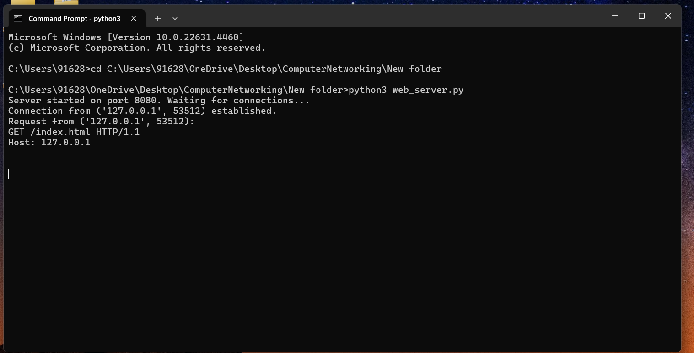

* Here, the server is ready and now we need to make a connection with the client file as shown below.
* The connection is successful and we can see the HTTP response on the command prompt as “**200 OK**”. The contents of HTML file named **“index.html”** are fetched.

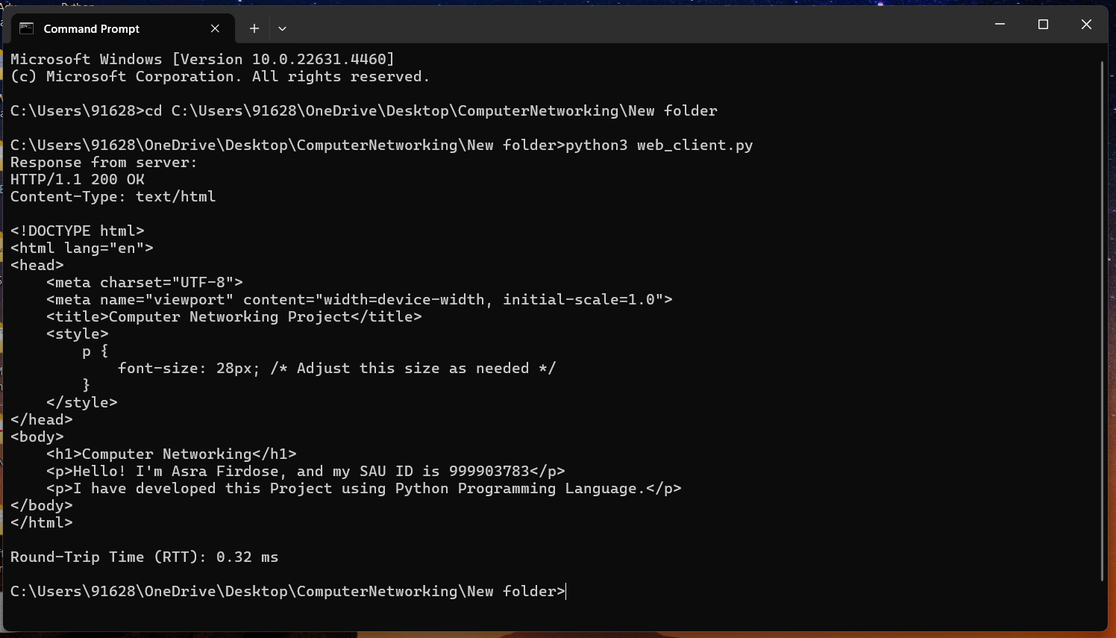

* Now, we are trying to make a connection request from browser.
* The file **“index.html”** is accessed through chrome by using **“localhost: 8080/index.html”.**
* We can see the contents of HTML file in the below screenshot.

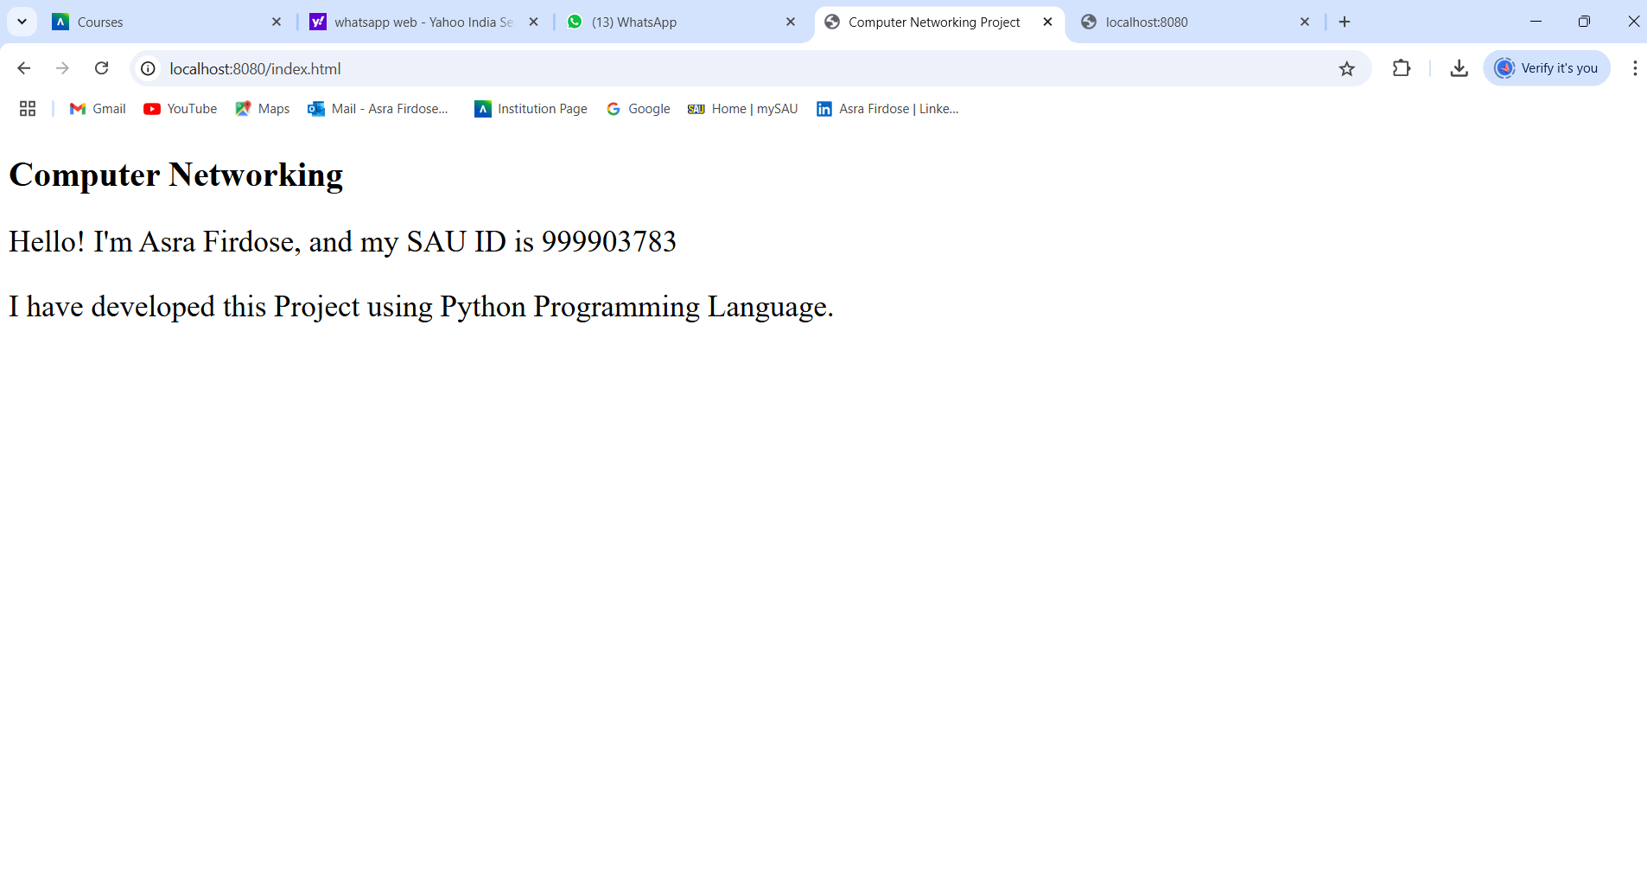

* When we try to access the file "index_dup.html” (which doesn’t exist at all), we get the HTTP response as “**404 Not Found**” as shown in the screenshot below.

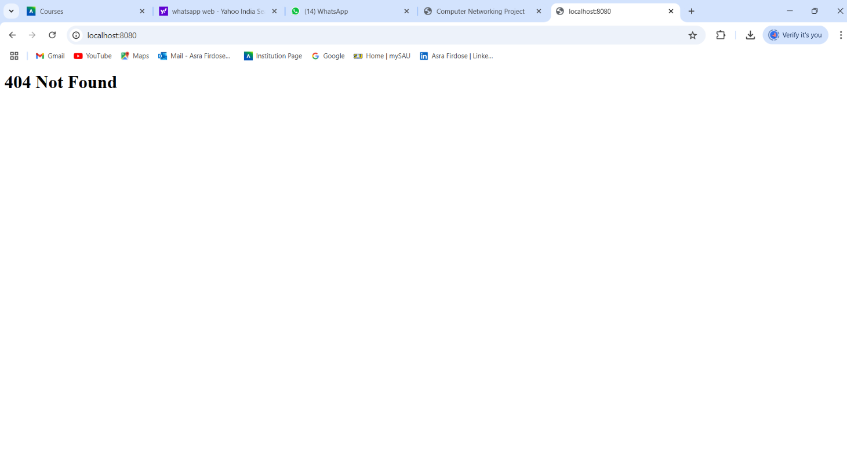

* In this setup, the server is running locally on port 8080, allowing us to access the index.html file directly by appending **/index.html** to **http://localhost:8080**.